**GIT**

Collabration : multiiple youser can connect in a single source

Backup : push everything

Multiple features : we get all code and changes and everything

Status tracking :

version controlling system

cvcs => centralized

dvcs => Distributed

GIT commands

git config --global user.name "name"

git config --global user.email ss@gmail.com

new git : git init for new git clone ulla project ne edkan

ls : for list the files in that directory

cd : change directry use tab for suggestion ls -a : or showing the git file not visible

tree : brew install tree

touch : command use to create a html file --> touch new.html

Status : git status

version creating :

git add name or . for all or use --all

git commit -m "what is this"

**after this we got a id and their is a head and master**

git log for showing the added

git checkout for cahnging the path

git --log all shwing all after change the id

**Branching**

git branch name for new branch

master is a branch it is default

git branch for showing the branches

**Merging braches**

git merge branchname it is fast forword merge

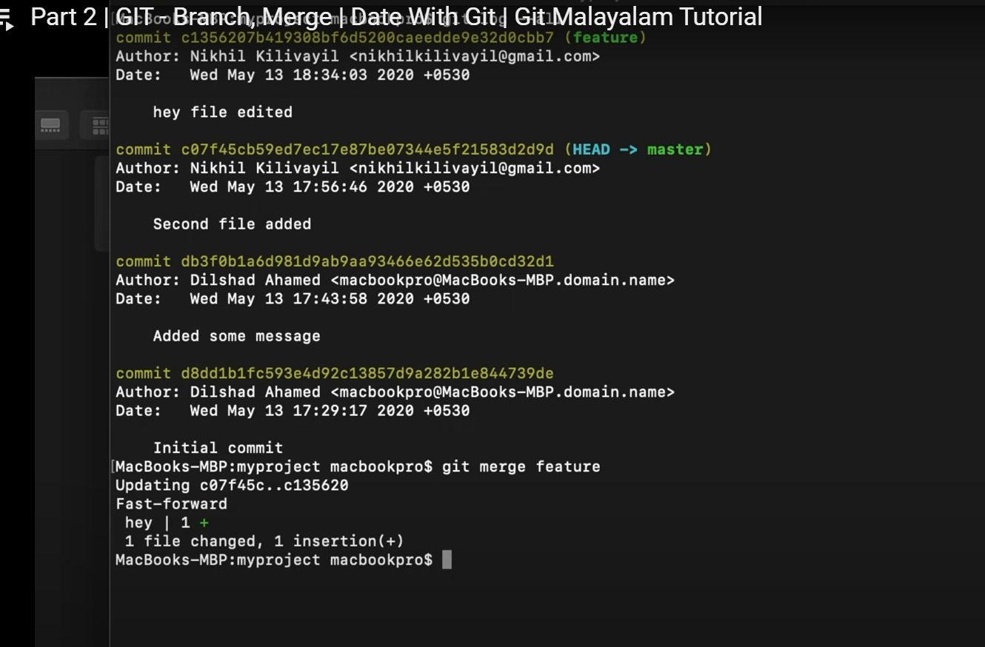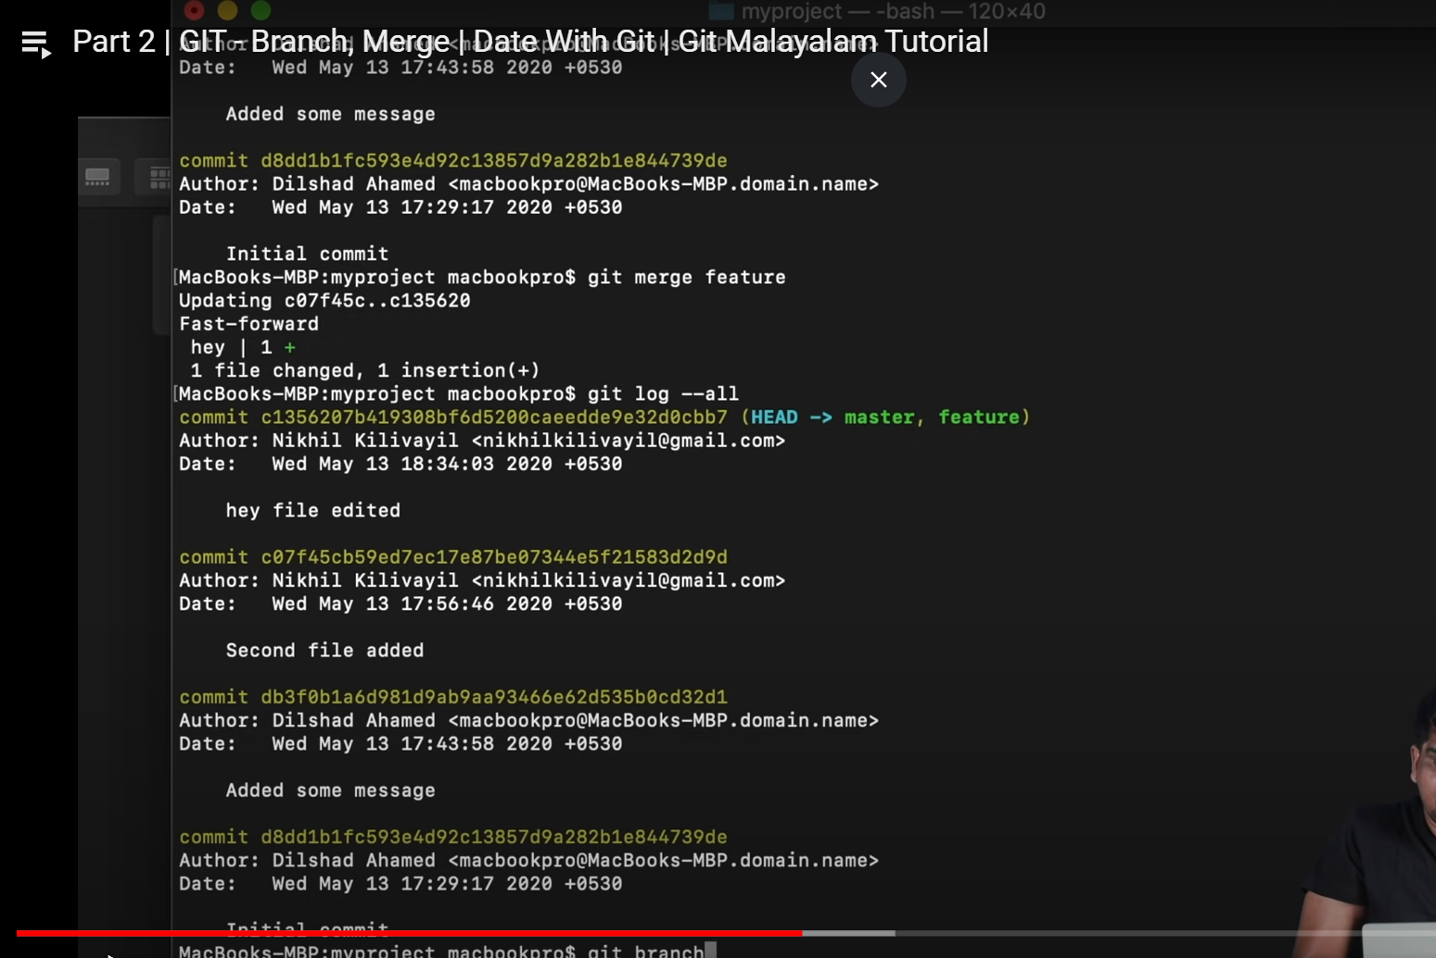

Recursive merge :

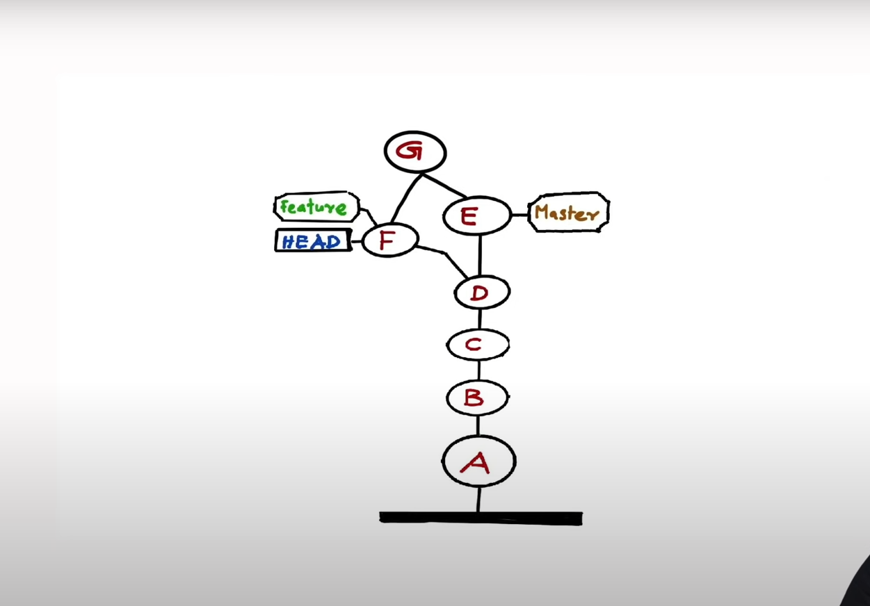

**Difference**

git diff

**stash**

git stash

**conflict**

**git push**

git remote add remote name

git push remotename branchnamen